**Exercise – 2.2**

Use **MATLAB (Simulink)** to

1. obtain the equivalent circuit parameters (referred to primary) by conducting the **open circuit** and **short circuit** tests on a given **single phase transformer**
2. calculate the **efficiency** and **voltage regulation** at 50% loading with 0.8 power factor lagging
3. **plot/display** the following for the above loading conditions:
   1. primary and secondary current
   2. real and reactive power at the primary and secondary terminals
   3. primary and secondary power factor
   4. efficiency

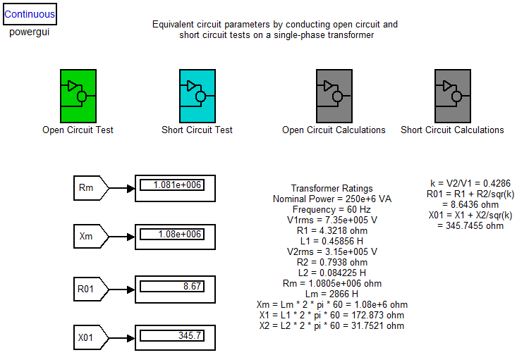**Simulink Circuit**:

1. **Equivalent circuit parameters**

|  |  |
| --- | --- |
| **Open circuit test** | **Short circuit test** |
| Apply rated voltage at primary and open circuit the secondary | Apply voltage at primary such that rated short circuit current flows through the secondary  Rated current at sec = 793.65 ampere ( VA / Vsec ) |

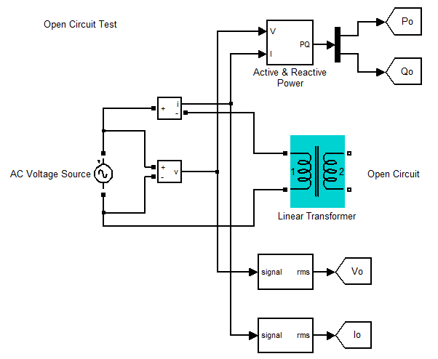

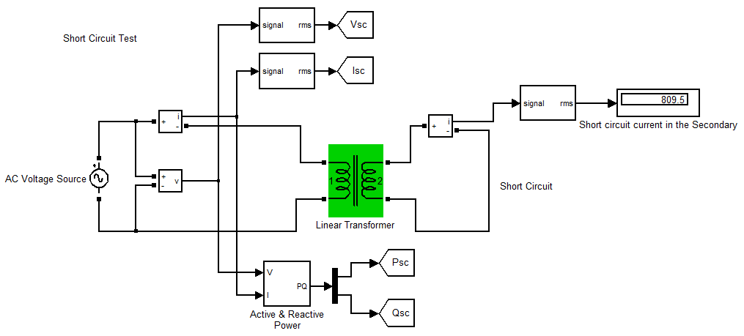

**Formulae:**

**Open Circuit Test**

$$∅ = \cos^{-1}{\frac{P_{o}}{V_{o}I_{o}}}$$

$$I_{w}= I_{o}\cos{∅}$$

$$I_{m}= I_{o}\sin{∅}$$

$$R_{m}= \frac{V_{o}}{I_{w}}$$

$$X_{m}= \frac{V_{o}}{I_{m}}$$

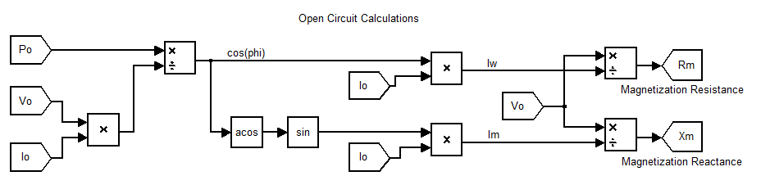

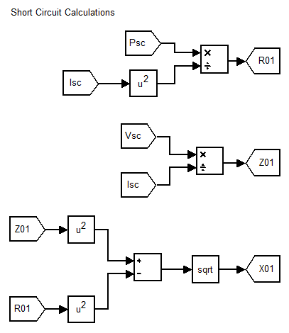

**Short Circuit Test**

$$R_{o1}= \frac{P_{sc}}{{I_{sc}}^{2}}$$

$$Z_{o1}= \frac{V_{sc}}{I_{sc}}$$

$$X_{o1}= \sqrt{{Z_{o1}}^{2}-{R_{o1}}^{2}}$$

1. 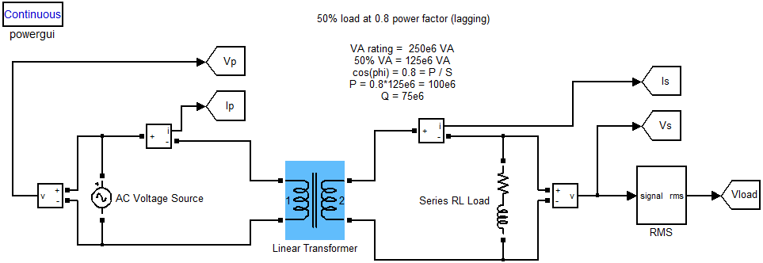**efficiency and voltage regulation**

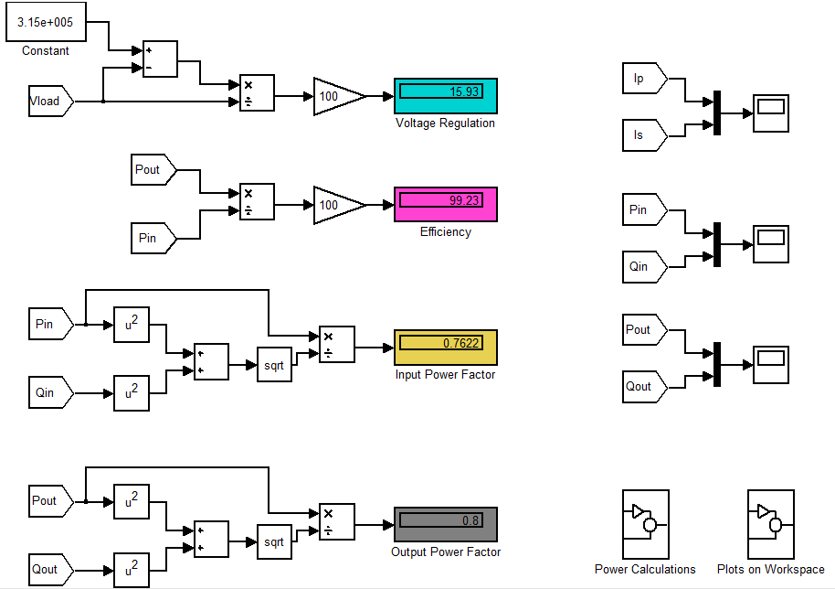

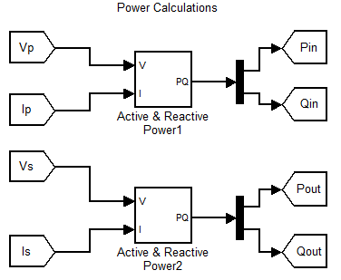

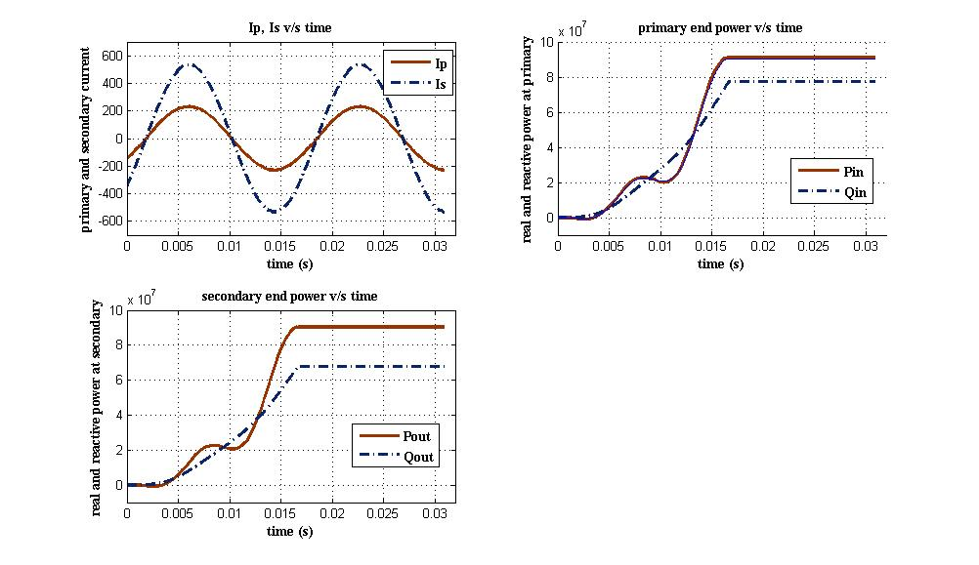

1. **plots for the above loading conditions**

**Results:**

Hence the equivalent circuit parameters of a single phase transformer obtained from the open circuit and short circuit tests are verified and the waveforms for specified load conditions are plotted using MATLAB (Simulink).